**UML DIAGRAM FOR BANK ACCOUNT**

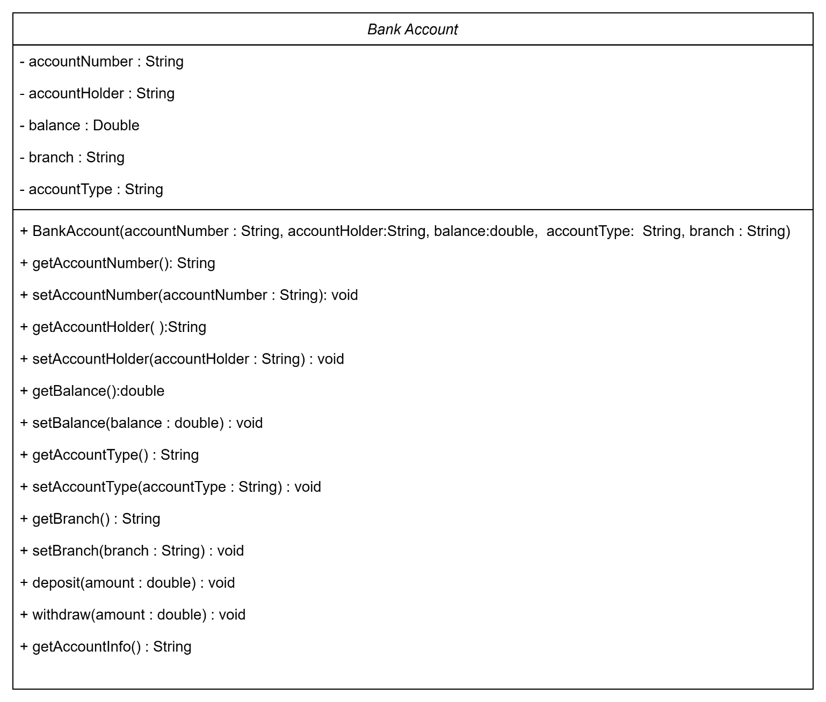

**DESIGN FOR PERSON**

